**Legal, Inc.**

MEMORANDUM

Date: February 15, 2019

To: C. Bean, CEO

From: J. Crow, SME

Subject: **Reimbursement for ECE4514 Digital Design II**

I am currently taking Digital Design II at Virginia Tech in Blacksburg, VA. The course teaches design practices to create computer hardware that follows complex procedures based on various inputs and outputs. I am asking for reimbursement for this course from Legal, Inc. because it will enhance my skills as a Subject Matter Expert (SME) in the field of Computer Engineering. It will also improve my contributions to Legal, Inc. I have attached a copy of my course syllabus for your review.

**Work Completed**

I have completed the following work in this course:

February 4-8 Designed computer hardware that follows a pre-existing protocol

to communicate with a digital audio chip.

February 11-15 Design a circuit which generates a 1 KHz square wave by

communicating with an on-board audio chip.

February 18-22 Write a Verilog design that can calculate and simulate a sine wave

using a fixed point interpretation.

**Work in Progress**

When representing numbers in any typical computer system, the binary number system is used. This is because numbers are represented by wires and any given wire can be “on” (representing a binary 1) or “off” (representing a binary 0). A set of wires therefore has a discrete set of values. For example, two wires can represent four different values: 0, 1, 2, and 3.

These limitations can cause inaccuracies when handling real world data if you don’t have a sufficient number of bits (wires) in a given binary value. Most electronic devices that interface with the world outside of a computer deal with values from a continuous set of values. An electric thermocouple, for instance, could supply any voltage on one wire within a given range depending on the temperature surrounding the device. This is known as an analog signal. An example of an analog to digital (or continuous to discrete) conversion is displayed below.

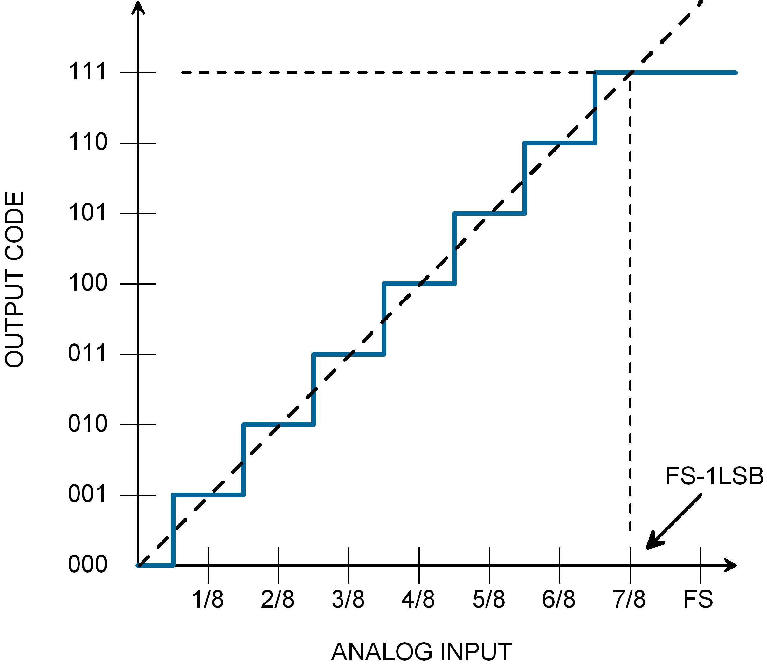

Figure

An important part of any computer system is analog to digital and digital conversion. A very common application of these conversions is audio. A computer will convert a digital audio file to an analog stream of data to speakers. Similarly, a microphone will convert analog sound input into digital values that can be stored within the computer system.

Along with representing numerical values, logical and arithmetic operations can be performed using digital logic. Electric circuits called logic gates can take two input wires and produce an output wire. Examples include :and” gates and “or” gates. Combinations of these gates can be used to perform mathematical operations such as addition, subtraction, and multiplication. Visual and behavioral representations of three different logic gates can be found below.

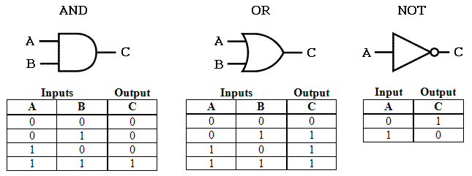

Figure

**Work to be Completed**

Still to be discussed in the course includes Verilog techniques and how a Verilog synthesis tool converts Verilog code into a digital circuit**.** A synthesis tool is an algorithm the interprets a description of a digital circuit and maps it onto a field programmable gate array, or FPGA. An FPGA consists of many interconnected cells that can be programmed to behave in various ways. By understanding how an algorithm interprets the code, Verilog can be written in a much more efficient and predictable manner.

**Conclusion**

In summary, I am taking ECE 4514 Digital Design II at Virginia Tech in Blacksburg, VA. The course covers design technics for complex computer hardware behavior. In the Work Completed section, I covered A, B, and C. In the Work in Progress section, I covered a major topic that is central to this field. In the Work to be Completed section, I outlined that we still need to cover D, E, and F. Since this course applies to my SME knowledge, I feel strongly that it will benefit my career and improve the contributions that I make to Legal, Inc. I am requesting that I be reimbursed for this course. If you need additional information, please feel free to contact me at cjonat1@vt.edu.

**Image Sources**

Figure 1

https://www.eetimes.com/document.asp?doc_id=1272445

Figure 2

https://www.muffwiggler.com/forum/viewtopic.php?t=163427&sid=125ecf2fe010cbf2aaddf7c7f3cf4399